**HO CHI MINH CITY UNIVERSITY OF ECONOMICS & FINANCE**

**FACULTY OF INFORMATION TECHNOLOGY**

**------------------------------**



**FINAL PROJECT**

**COURSE: PROJECT**

**PROJECT TITLE: WEATHER FORCAST**

**Class ID: ITE1459 B05**

Lecturer: Msc.Trần Thành Công

Student Name:

Văn Hoàng Phúc 185050810

Đặng Nguyễn Kim Long 185050510

Đặng Minh Nhật 185050814

*Ho Chi Minh City, January, 2022.*

|  |  |
| --- | --- |
| https://user-cdn.uef.edu.vn/newsimg/files/logo%20nhan%20dien%20TH/3.jpg | **HCM UNIVERSITY OF ECONOMICS AND FINANCE**  **FACULTY OF INFORMATION TECHNOLOGY** |

**FINAL PROJECT**

**SUBJECT: PROJECT   
Lecturer: Msc. Trần Thành Công**

**PROJECT NAME**

**WEATHER FORECAST**

*Team Members:*

1. Văn Hoàng Phúc - 185050810
2. Đặng Nguyễn Kim Long - 185050510
3. Đặng Minh Nhật - 185050814

Ho Chi Minh city – 2022

Contents

CHAPTER 1. INTRODUCTION 1

1.1. PURPOSE 2

1.2. SCOPE 2

CHAPTER 2. DATASET 3

2.1. COLLECTING DATA 3

2.2. DATA UNDERSTANDING 4

2.2.1. DataFrame 4

2.2.2. Missing Values 5

2.2.3. Outliers 5

2.2.4. The Importance Of Features 7

2.3. DATA PREPARATION 8

2.3.1. Dropping Feature 8

2.3.2. Creating Output 8

2.3.3. Handling Missing Values 9

2.3.4. Handling Outliers 10

2.3.5. Preprocessing and Splitting Data 11

CHAPTER 3. BACKGROUND 11

3.1. FLASK AND CHART.JS 11

3.1.1. Flask 11

3.1.2. Chart.JS 12

3.2. MACHINE LEARNING ALGORITHMS 12

3.2.1. Random Forest 12

3.2.2. KNN 12

3.2.3. Neural Networks 12

3.3. EVALUATION METHODS 13

3.3.1. R-Squared 13

3.3.2. Mean Squared Error 13

3.4. MODELING 13

3.4.1. Random Forest 13

3.4.2. KNN 14

3.4.3. Neural Networks 15

3.5. EVALUATING MODEL 15

3.5.1. Evaluation of Random Forest model 15

3.5.2. Evaluation of KNN model 17

3.5.3. Evaluation of Neural Networks model 18

CHAPTER 4. DEPLOYMENT 20

4.1. IBM WATSON 20

4.2. USE CASE DIAGRAM 22

4.3. CLASS DIAGRAM 25

4.4. COMPONENT DIAGRAM 25

4.5. IMPLEMENTATION 26

CHAPTER 5. CONCLUSION 34

5.1. RESULT 34

5.2. LIMITATIONS 34

CHAPTER 6. REFERENCES 35

**LIST OF FIGURES**

Figure 2‑1: Data Access Viewer – NASA POWER 3

Figure 2‑2 : File dataset of weather 4

Figure 2‑3 : Display dataset 4

Figure 2‑4 : Display rows, columns and describe dataset 5

Figure 2‑5 : Checking missing values 5

Figure 2‑6 : Showing dataset by boxplot 6

Figure 2‑7 : Showing dataset by histogram 6

Figure 2‑8 : Importance of features 7

Figure 2‑9: Dropping some features 8

Figure 2‑10 : Creating output 9

Figure 2‑11 : Dropping missing values 10

Figure 2‑12 : Handling outliers by dropping ‘Precipitation corrected(mm/hour)’ feature 10

Figure 2‑13 : Preprocessing data 11

Figure 2‑14 : Splitting data 11

Figure 3‑1 : Training and predicting by Random Forest 14

Figure 3‑2 : Finding parameter k 14

Figure 3‑3 : Training and predicting by KNN 15

Figure 3‑4 : Training and predicting by Neural Networks 15

Figure 3‑5 : R squared of training and testing of Random Forest 16

Figure 3‑6 : Calculating mean squared error of Random Forest model 16

Figure 3‑7 : Scatter plot of Random Forest model 17

Figure 3‑8 : R squared of training and testing of KNN model 17

Figure 3‑9 : Calculating mean squared error of KNN model 18

Figure 3‑10 : Scatter plot of KNN model 18

Figure 3‑11 : R squared of training and testing of Neural Networks model 19

Figure 3‑12 : Calculating mean squared error of Neural Networks model 19

Figure 3‑13 : Scatter plot of Neural Networks model 20

Figure 4‑1 : Public the model online 21

Figure 4‑2 : Deployed model 21

Figure 4‑3 : Get API from deployed model 21

Figure 4‑4 : Use case of web user 22

Figure 4‑5 : Use case of admin and hyper admin 23

Figure 4‑6 : Admin sequence 25

Figure 4‑7 : System Component 25

Figure 4‑8 : Login page 26

Figure 4‑9 : Home page 27

Figure 4‑10 : Details in home page 27

Figure 4‑11 : About page 28

Figure 4‑12 : Services page 28

Figure 4‑13 : News page 29

Figure 4‑14 : Blog page 29

Figure 4‑15 : Blog post page 30

Figure 4‑16 : Contact page 30

Figure 4‑17 : choosing weather dataset 31

Figure 4‑18 : Uploading dataset 31

Figure 4‑19 : Visualizing predictions by bar chart 32

Figure 4‑20 : Visualizing predictions by line chart 32

Figure 4‑21 : Download predictions 33

Figure 4‑22 : Predictions CSV file 33

Figure 4‑23 : Predictions PDF file 34

**LIST OF TABLES**

Table 4‑1 :Use-case specification of web user 22

Table 4‑2 : Use-case specification of hyper admin 24

Table 4‑3 : Use-case specification of admin 24

# INTRODUCTION

Weather forecasting is a very new and strange saying to us humans at the beginning of the last century. We, humans, have experienced natural disasters due to floods or droughts, prolonged winter colds, or early droughts without knowing it, without expecting it. To be able to go through these dilemmas, we humans are gradually learning to recognize the gradually changing weather. According to historical records, the perception of weather is learned by humans and followed by animals, insects, or plants because animals and plants often have a rather sensitive sense of the change in their environment. And now with the remarkable evolution of mankind, people are in the process of modernizing and developing the country. With the formation of technology, people can easily develop artificial satellites and launch them outside the earth, which makes it easier for us humans to observe the climate moving across continents around the world but this is also difficult when geologists predict and calculate weather models like calculated humidity, wind, etc. Weather is a dilemma that we cannot define. We do not know how the weather will change, how sunny or rainy it will be, what region or hour it will change, what temperature it will be. So forecasting the weather is key to getting weather information results that can lead to emergency services operations, energy management, flood warnings or maritime operations, and more. To make it easier, we have to collect a lot of data, so this has helped us continue machine learning.

Machine learning is a subfield of artificial intelligence. The goal of machine learning generally is to understand the structure of data and fit that data into models that can be understood and utilized by people. Any technology user today has benefitted from machine learning. Facial recognition technology allows people who use social media platforms to tag and share photos of friends. Another technology in the machine learning field is optical character recognition technology, which can help to convert images of text into movable types. Recommendation engines, powered by machine learning, suggest what movies or television shows to watch next based on user preferences, thank this technology people can know more about great videos on the internet.

With the adaptation of Machine Learning to weather prediction, we need to provide the speed and accuracy of artificial intelligence technology, which gives more opportunities to be able to produce more forecasting results. In this final project, I apply some algorithms which I learned from the machine learning subject, such as Radom Forest, KNN and Neural Networks to build up models to predict temperature in the future. Besides, I choose the best model among the models use for training and deploy it into a website to predict temperature in the future.

## PURPOSE

Based on the knowledge I learned from machine learning, about preparing datasets, algorithms for the model, and evaluating the quality of the model, I built and designed a mathematical model to predict the temperature in the future. Weather prediction is a regression problem, so the solution to this problem is to use 3 algorithms in supervised learning, namely Random Forest, KNN, Neural Networks to predict the weather, and I will judge which one is best for this problem.

In addition, goals through this project can be defined to think about understanding the data, preparing and reprocessing the data, applying the model to the data, evaluating the quality of the model, and deploy the best model into website to predict the temperature in the future. I also understand more about the algorithms for the model, how it works with the data set and framework flask to deploy model into website.

## SCOPE

* The project is implemented on the basic of the machine learning subject, the knowledge about data preparation, building model, evaluating model and implementing model.
* The scope of the project is limited in understanding and preparing dataset for model, build up the model for weather forecast and deploy the model into website.

# DATASET

## COLLECTING DATA

The first step in this project, we have to collect the dataset for mathematical model to predict the temperature of a specific area in the future, so I will find data on some websites which have information about the weather. In this case study, the website that we use to collect the dataset is <https://power.larc.nasa.gov/data-access-viewer/>, this website is owned by Nasa, and it allows people to download the weather dataset. We can also adjust the features of dataset before we download it.

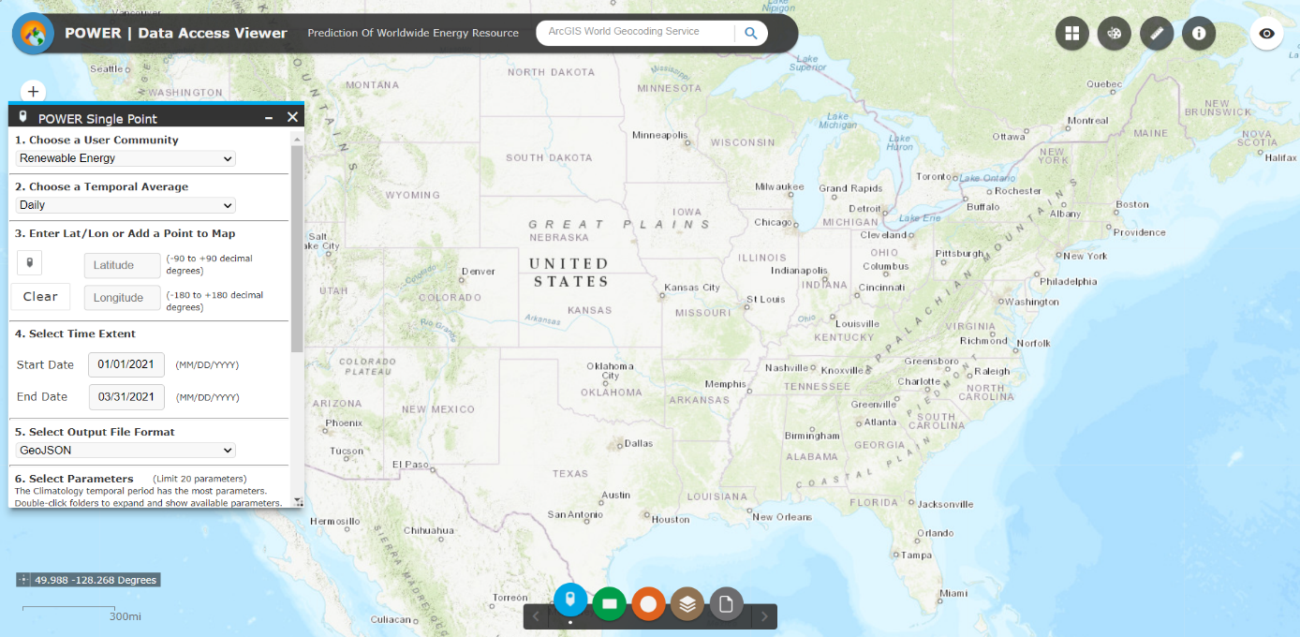

Figure ‑: Data Access Viewer – NASA POWER

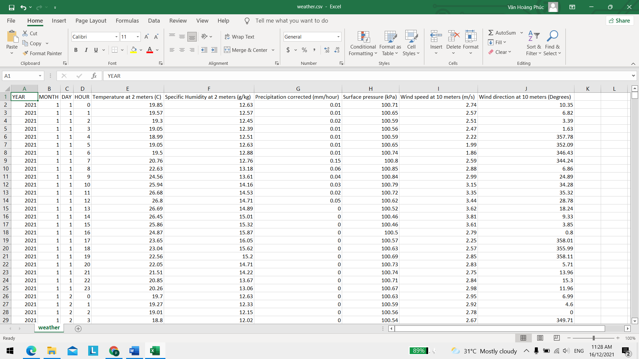

Figure ‑ : File dataset of weather

## DATA UNDERSTANDING

### DataFrame

After downloading the dataset, we use some commands in python to read dataset as a dataframe structure. we also print out the dataset and the number of columns, rows, features of the dataset. There are totally 2160 rows, 10 columns and 10 features.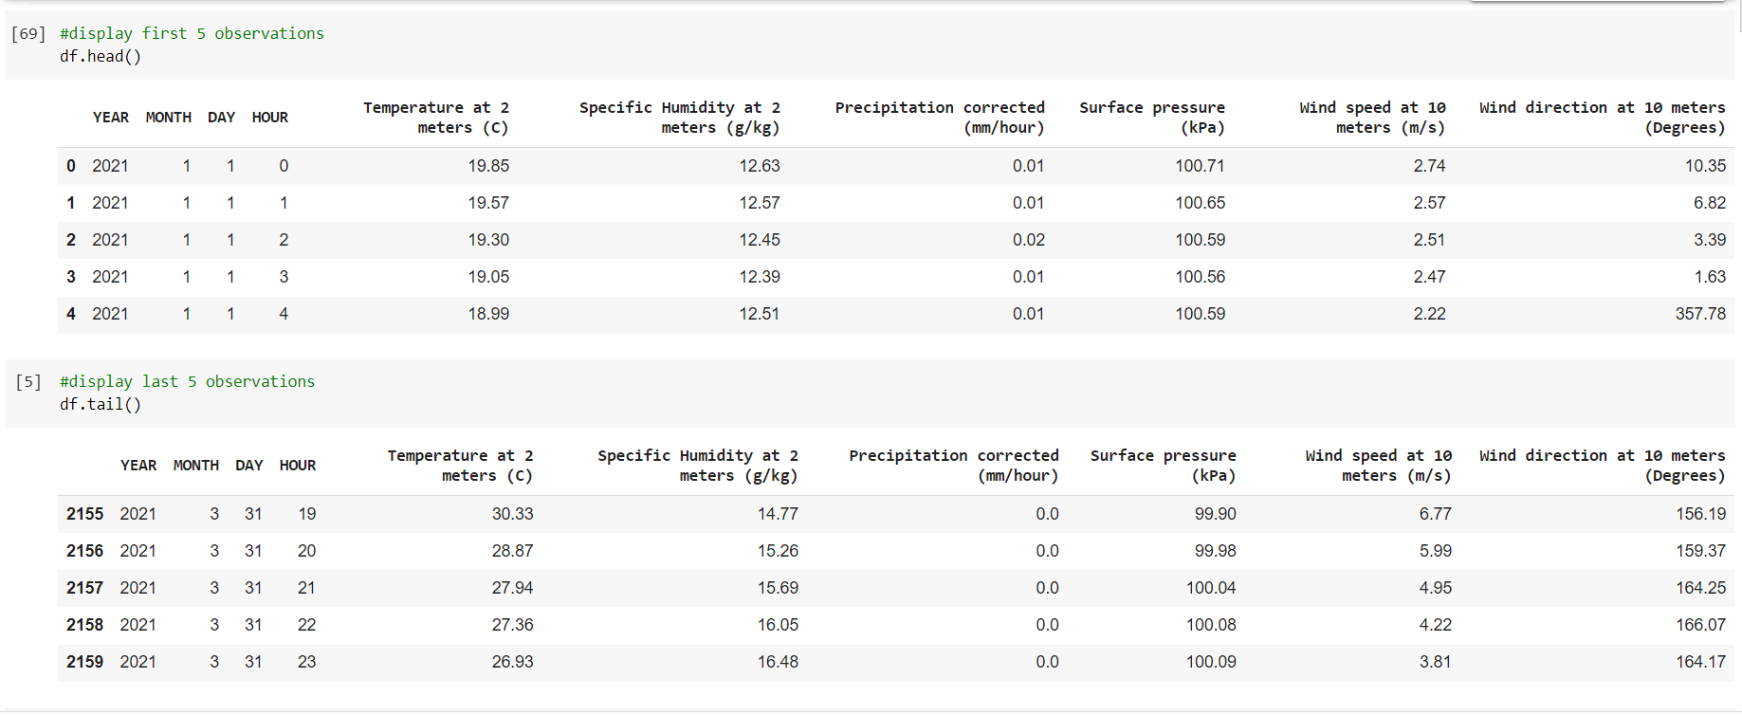

Figure ‑ : Display dataset

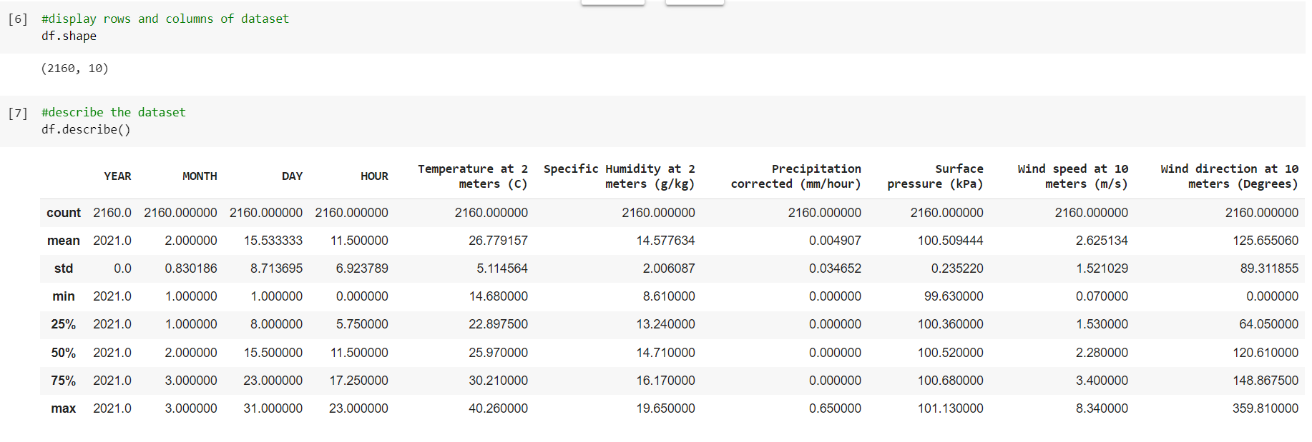

Figure ‑ : Display rows, columns and describe dataset

### Missing Values

Next, we use python command to check missing values in the dataset. Missing values can cause some problems to our mathematical models, so we have to check their existence in our dataset. Fortunately, there are no missing values in our dataset.

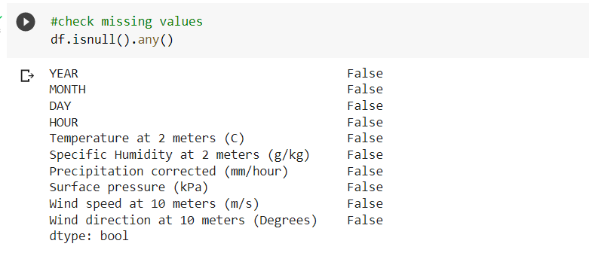

Figure ‑ : Checking missing values

### Outliers

Outliers are values that lie outside (they are much smaller or larger than) most of the other values in the dataset. Outliers might bring drawbacks to our mathematical models, so we have to check the existence of them. we use boxplot and histogram to check outliers in dataset.

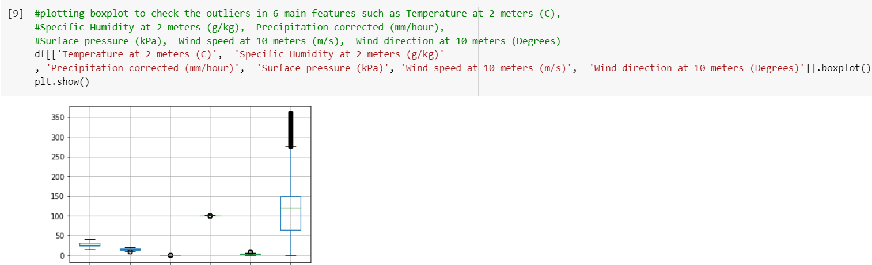

Figure ‑ : Showing dataset by boxplot

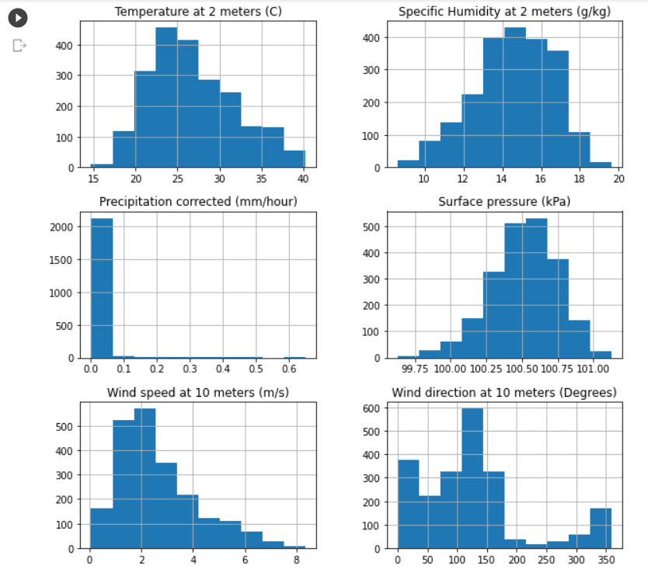

Figure ‑ : Showing dataset by histogram

### The Importance Of Features

Next, we use the python command to check importance of main features of the dataset. After checking the importance of each feature, we realize that the importance of ‘Temperature at 2 meters (C)’ is the highest, while the feature ‘Precipitation corrected (mm/hour)’ is the lowest. Based on this statistic table, we can know which features are needed for models.

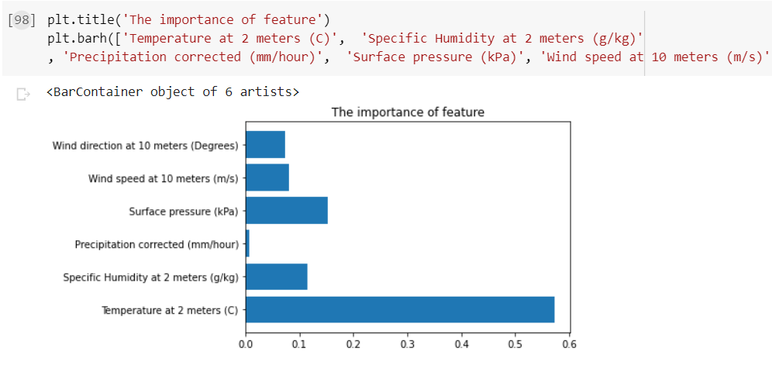

Figure ‑ : Importance of features

## DATA PREPARATION

### Dropping Feature

After we analyze and understand the dataset, we have to prepare the dataset for our mathematical models. In this section, we drop some features such as ‘YEAR’, ‘MONTH’, ‘DAY’, ‘HOUR’ which are not necessary for our models.

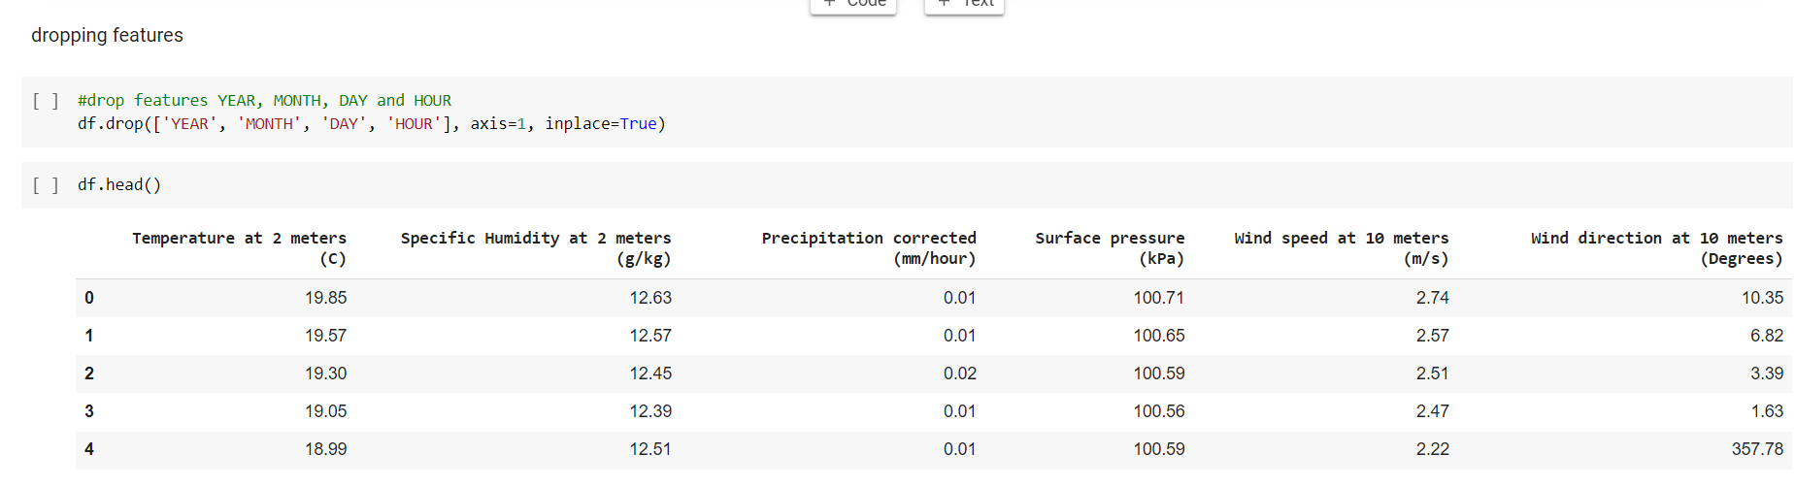

Figure ‑: Dropping some features

### Creating Output

In this step, we have to create the output for the dataset, which is the results of model’s prediction. The output that we want to receive from our models is temperature of tomorrow.

The output is created by using the feature ‘Temperature at 2 meters (C)’. Taking values from the 25th position to the end of this features, then we put them into new columns called ‘Temperature_after_day’ to create the output.

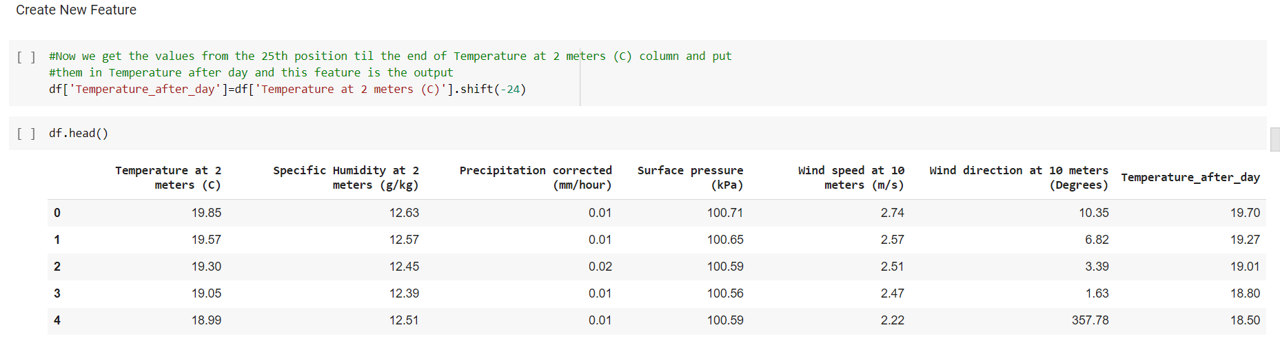

Figure ‑ : Creating output

### Handling Missing Values

In the previous step, creating the output for dataset cause missing values, so we have to handle missing values to make our models give the best results. we try some methods of handling missing values, and then we realize that dropping them is the best method in our study case.

Almost missing values come from the output of dataset. In order to handle missing values, we use the command ‘df.dropna(inplace = True)’ and check dataset again to make sure there are no missing values in the dataset.

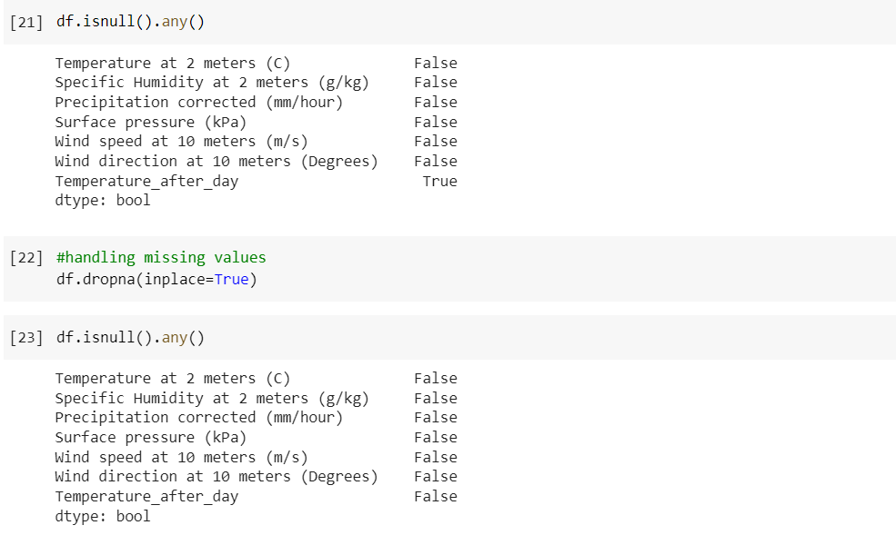

Figure ‑ : Dropping missing values

### Handling Outliers

In this stage, we handle outliers in dataset to make dataset become better. Almost outliers in features do not affect results of models, but there is only one feature called ‘Precipitation corrected (mm/hour)’ which contains a lot of outliers, and the importance of this feature is the lowest, so we decide to drop out this feature to make the dataset become better. For the other features which also contain outliers, we do nothing with them because they do not affect the results of models.

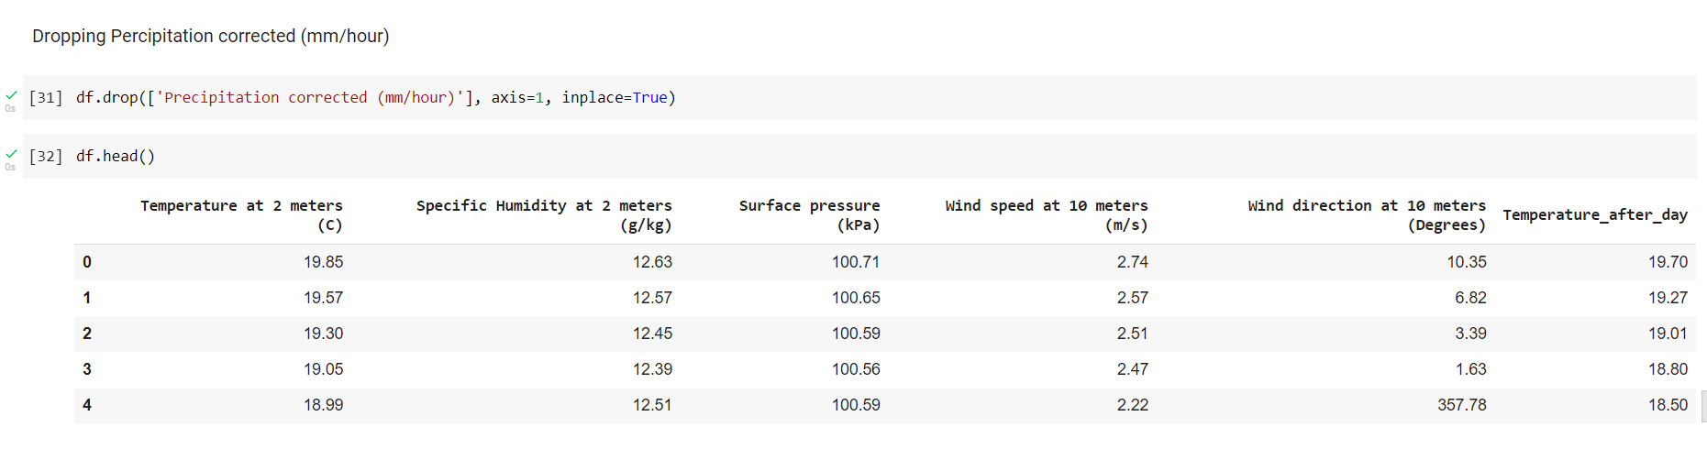

Figure ‑ : Handling outliers by dropping ‘Precipitation corrected(mm/hour)’ feature

### Preprocessing and Splitting Data

In this section, we preprocess the dataset and split it into 2 parts, 70% of data for training and 30% of data for testing. The method that we use to preprocess dataset is mean removal method, it can help to remove mean from every feature so that it could center on zero. It also helps to remove bias from the feature.

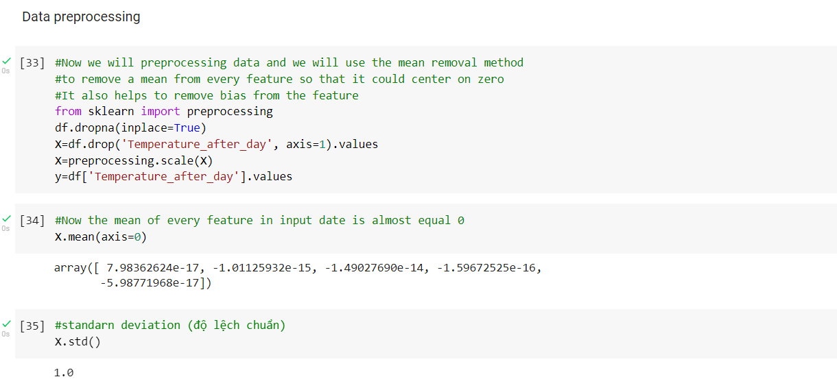

Figure ‑ : Preprocessing data



Figure ‑ : Splitting data

# BACKGROUND

## FLASK AND CHART.JS

### Flask

Flask is a web framework, a microframework and a python module that enables rapid web application development. Flask is designed to be easy to get started quickly and to scale for complex applications, supporting extensions that can add application features. It has outstanding features like URL routing, template engine.

### Chart.JS

Chart.js is a javascript library that allows us to draw various charts and tables using the Html 5 canvas element. It allows providing an easy, simple and powerful way to design graph types that meet basic user needs. It supports 8 types of graphs: Line, Bar, Doughnut, Pie, Radar, Polar Area, Bubble, Scatter.

## MACHINE LEARNING ALGORITHMS

### Random Forest

Random forest is a supervised learning algorithm in machine learning, which can use for both regression problems and classification problems. Random forest builds up by many decision trees on different samples and takes their majority vote for classification problem and average in case of regression problem. Random forest algorithm can bring some benefits such as it can solve the dataset which contains continuous variables as in the case of regression problem and categorical variables as in the case of classification problem. Another benefit of random forest is calculating the importance of each feature in dataset.

### KNN

KNN stands for k-nearest neighbors, which is a supervised learning algorithm in machine learning and KNN can use for both classification problem and regression problem. In KNN algorithm, nearest neighbors are data points which have minimum distance in feature space from our new data points. There are two important things in KNN, the first thing is the parameter k, which is the number of data points we consider in our implementation and the second thing is distance measures such as Hamming distance, Manhattan distance, Minkowski distance.

### Neural Networks

Neural networks algorithm is one of the most popular algorithms in machine learning, the way that neural networks is taking several inputs, then process them through multiple neurons from multiple hidden layers, and output layer which is the final layer will return the result, these processes called “Forward Propagation”. The following step, the result is compared with the actual output, and the task here is to make the result closes to the actual output. In order to make the result closes to actual output, we try to optimize the weights of neurons that can cause the error for result and this happens while traveling back to the neurons of the neural networks and finding the error, this process called “Backward Propagation”.

## EVALUATION METHODS

### R-Squared

R-Squared is the suitable measurement for linear regression models, this statistic shows the proportion of the variance in the dependent variable that the independent variables explain generally. In regression problem, strength of relationship between linear regression model and dependent variable is measured by R-Squared.

### Mean Squared Error

Mean Squared Error or MSE is the mean squared difference between estimated values and actual values and MSE is very popular in statistic. MSE is a risk function, which corresponds to the expected value of squared error loss.

## MODELING

When we finish data preparation, we will choose mathematical models and fit the data that we have just analyzed and prepared into model to predict the temperature of a specific area in the future.

### Random Forest

Firstly, we choose Random Forest regression model, and we also choose suitable parameters for this model such as the number of trees, random_state, max_feature, max_depth and min_samples_leaf to get the best result. When we finished choosing parameters, we train model with training dataset and predict with testing dataset.

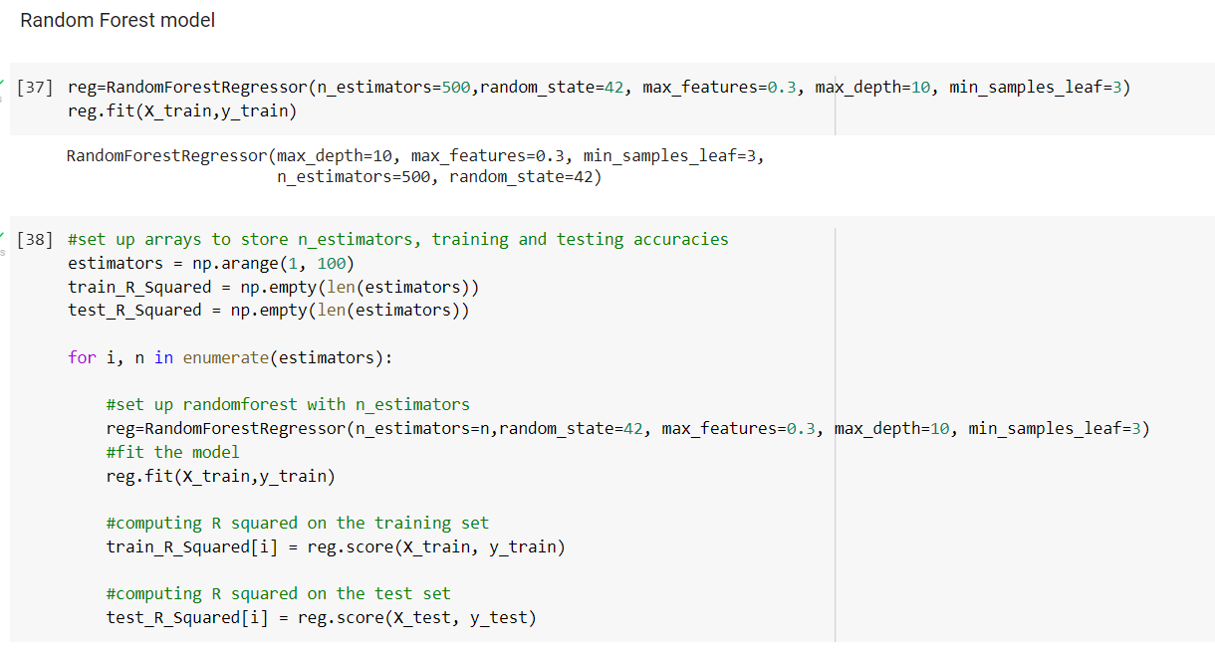

Figure ‑ : Training and predicting by Random Forest

### KNN

Secondly, we use KNN for the dataset and have to find out which is the best number for parameter k. The method that we use to find parameter k is using GridSearchCV which is a library function that is a member of sklearn’s model_selection package, this one will help us choose the best parameter k for model.

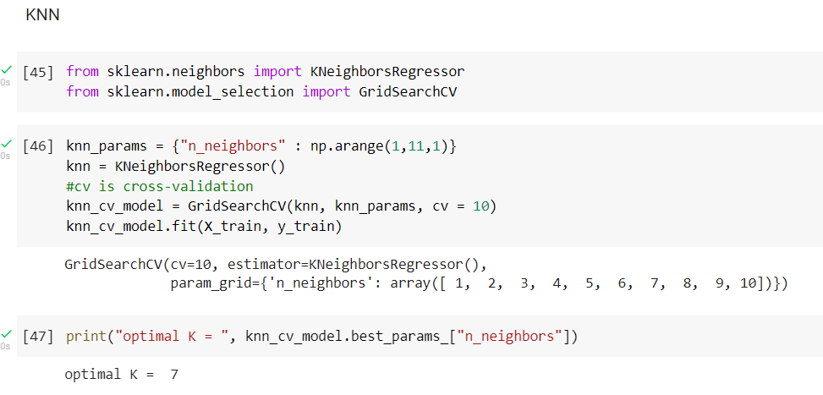

Figure ‑ : Finding parameter k

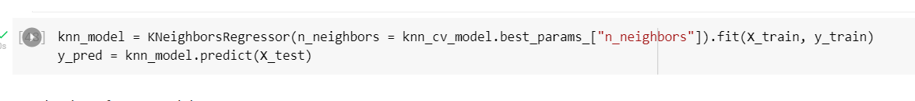

Figure ‑ : Training and predicting by KNN

### Neural Networks

Thirdly, using Neural Networks regression model, and there are some paramters in this model, such as solvers, hidden_layer_sizes, max_iter, activation. The activation in this model is “relu”.

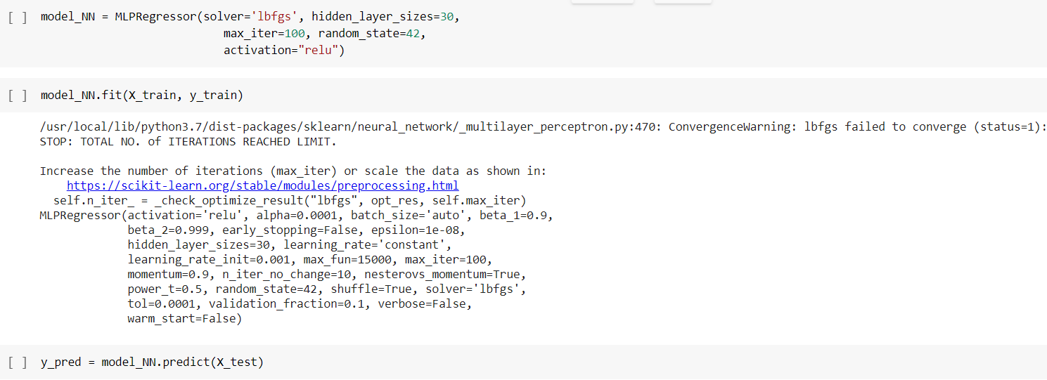

Figure ‑ : Training and predicting by Neural Networks

## EVALUATING MODEL

Evaluating is a necessary step, it gives us the information about the quality of model. With three mathematical models that we apply for this project such as Random Forest, KNN and Neural Networks, they give us good predictions. The measurements that we use to evaluate the model are R squared, and mean squared error (MSE).

### Evaluation of Random Forest model

The figures for Random Forest are pretty good, R squared of training and testing are pretty high, at about 96.1% and 92.6% respectively. Calculation of MSE give us a value about 1,9523570087 and we think that is the good value for model.

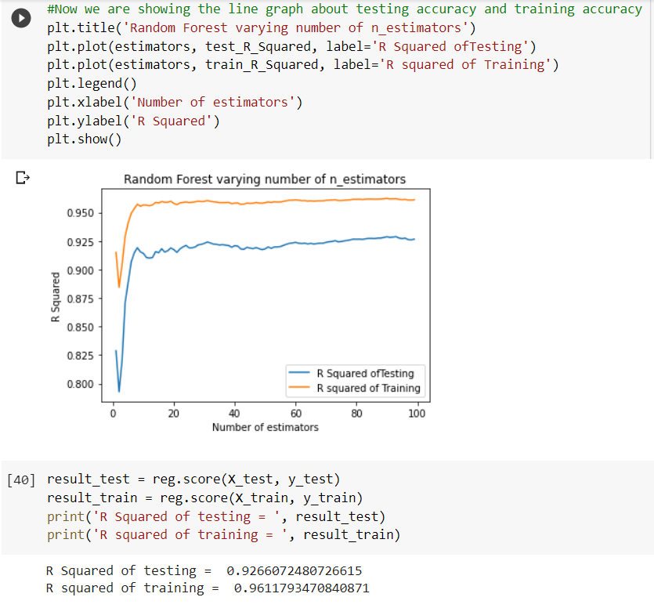

Figure ‑ : R squared of training and testing of Random Forest

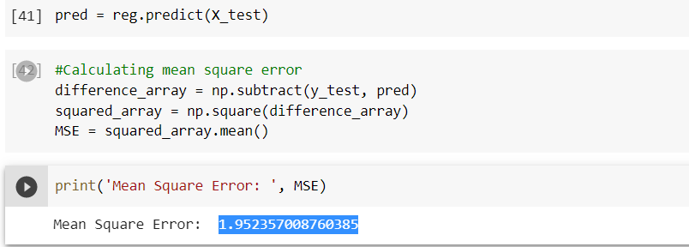

Figure ‑ : Calculating mean squared error of Random Forest model

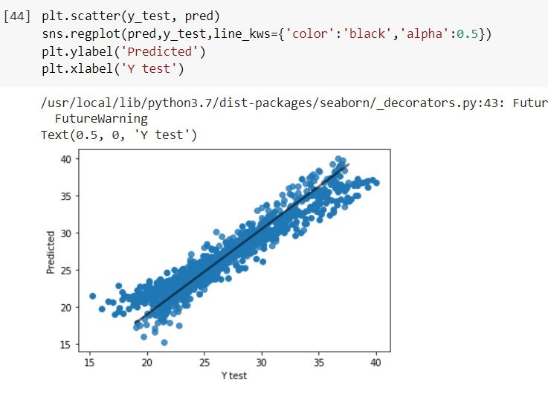

Figure ‑ : Scatter plot of Random Forest model

### Evaluation of KNN model

The figures for KNN model are almost like the figures for Random Forest, about 96% for R squared of training and 94.7% for R squared of testing. The figure for mean squared error is still 1,9523570087.

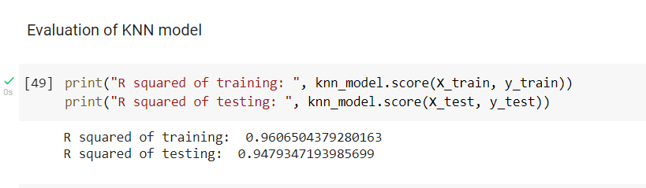

Figure ‑ : R squared of training and testing of KNN model

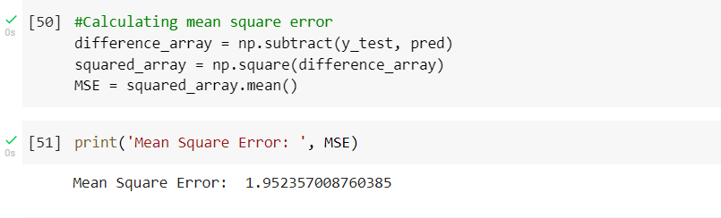

Figure ‑ : Calculating mean squared error of KNN model

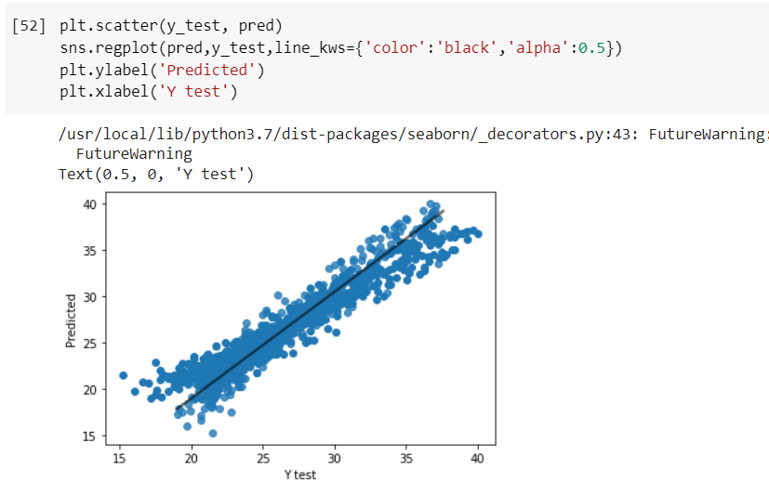

Figure ‑ : Scatter plot of KNN model

### Evaluation of Neural Networks model

The figures for R squared of training and testing in Neural Networks model are slightly lower than Random Forest model and KNN model, at about 96.1% for training and 95.9% for testing. The mean squared error is still 1,9523570087.

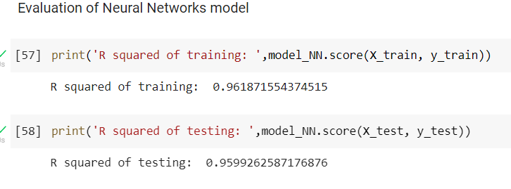

Figure ‑ : R squared of training and testing of Neural Networks model

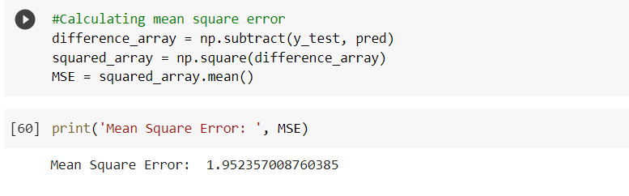

Figure ‑ : Calculating mean squared error of Neural Networks model

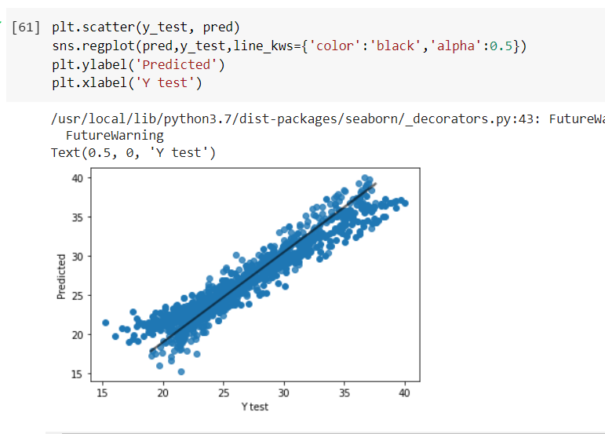

Figure ‑ : Scatter plot of Neural Networks model

# DEPLOYMENT

## IBM WATSON

In this stage, we public the model online and we can take the API of the model and apply for website or application. The online service that we use to public our model called IBM Watson. IBM Watson allows user open notebook file and run the code directly, so we can run python code on this website and public the model.

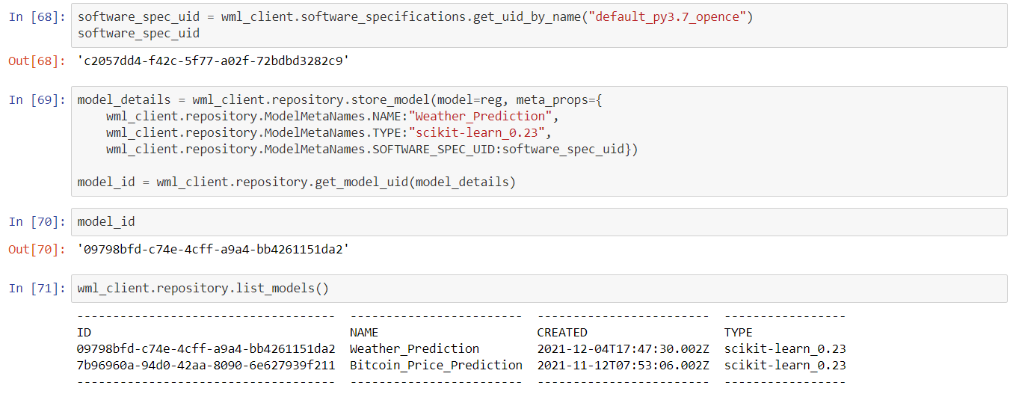

Figure ‑ : Public the model online

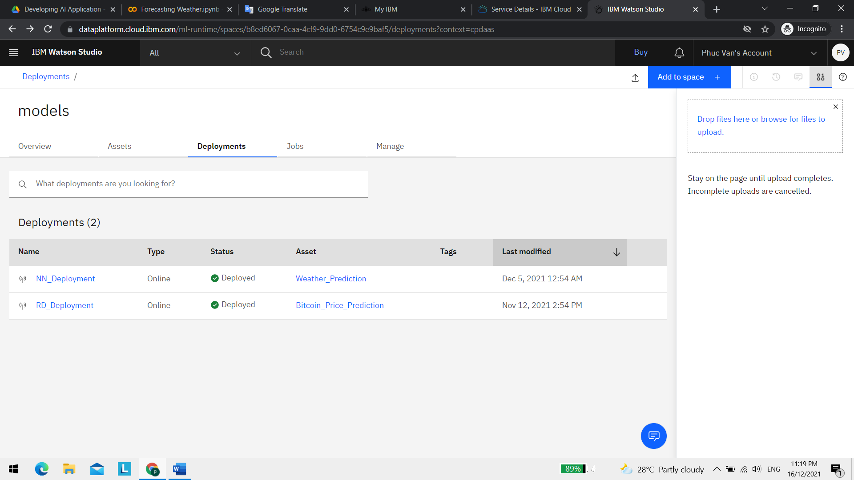

Figure ‑ : Deployed model

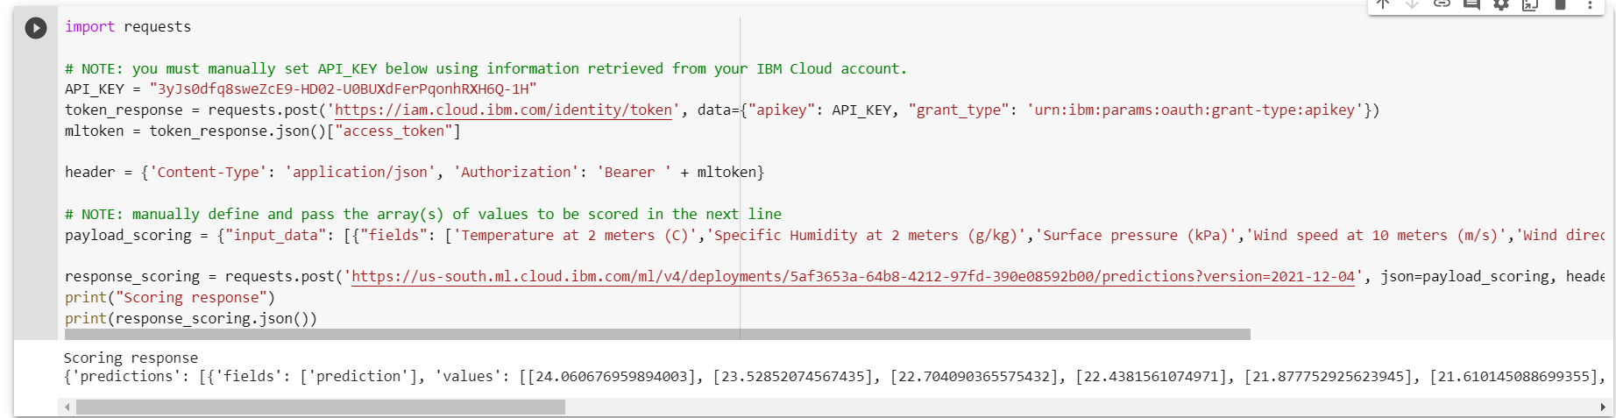

Figure ‑ : Get API from deployed model

## USE CASE DIAGRAM

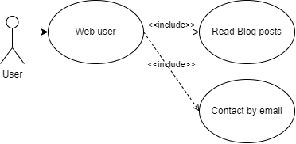

Figure ‑ : Use case of web user

|  |  |
| --- | --- |
| Use Case ID | UC 1.1 |
| Use case name | Web User |
| Description | People can read blogs about the weather, and they can contact with admins through email |
| Actor(s) | User |
| Pre-Condition(s): | * Internet connections to use website access |
| Flow | Basic   * Users accessing the web * Select the "blog post" section to view weather information |
| Post-Condition(s): | * Has been read |

Table 4‑1 :Use-case specification of web user

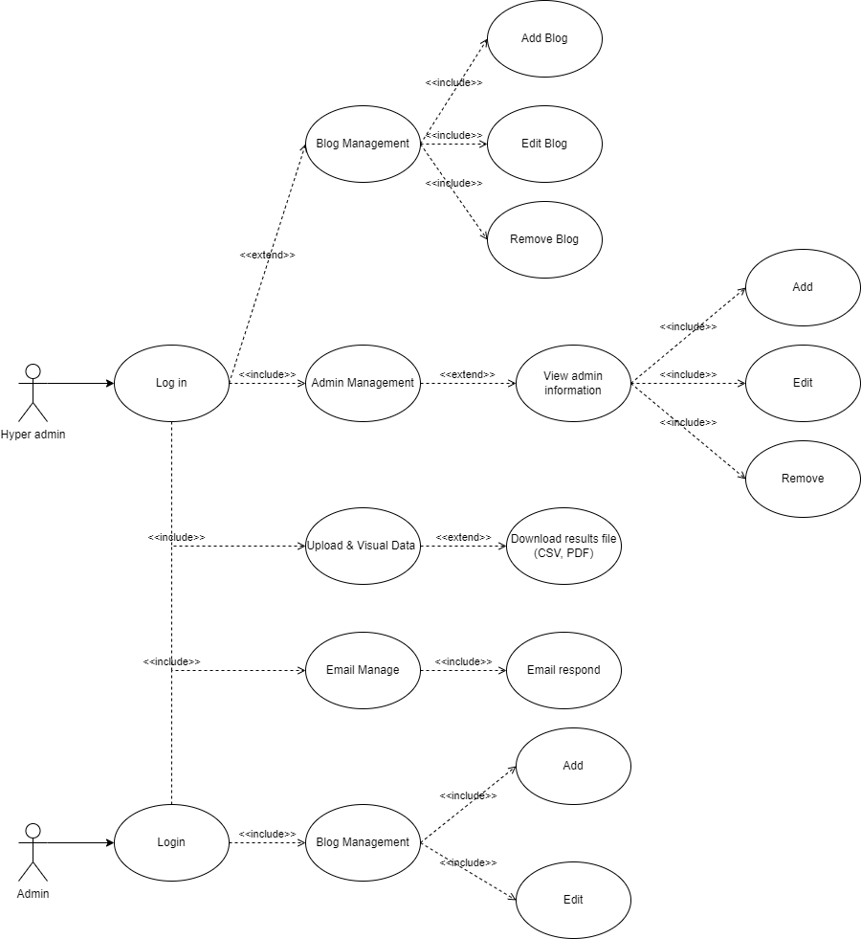

Figure ‑ : Use case of admin and hyper admin

|  |  |
| --- | --- |
| Use Case ID | UC 1.2 |
| Use Case Name | Hyper admin |
| Description | Hyper admin can manage information of admins, blog posts, and use the weather forecast function of website |
| Actor(s) | Hyper admin |
| Pre-Condition(s) | * Admin account has been created * Admin account has been decentralized * Internet connections to sign in |
| Flow | Basic   * Hyper admin must visit the website * Confirm management system access * Blog management permissions are allowed * Allows blog post editing using hyper admin permissions |
| Post-Condition(s) | * Blog management permissions have been allowed |

Table 4‑2 : Use-case specification of hyper admin

|  |  |
| --- | --- |
| Use Case ID | UC 1.3 |
| Use Case Name | Admin |
| Description | Admin can write and edit blog posts, but they cannot remove them. They can also use weather forecast function to predict temperature in the future |
| Actor(s) | Admin |
| Pre-Condition(s) | * Admin account has been created * Admin account has been decentralized * Internet connections to sign in |
| Flow | Basic   * Hyper admin must visit the website * Confirm management system access * Blog management permissions are allowed * Allows blog post editing using hyper admin permissions |
| Post-Condition(s) | * Blog management permissions have been allowed |
| Non-Functional Requirement | * Can not remove blog post |

Table 4‑3 : Use-case specification of admin

## CLASS DIAGRAM

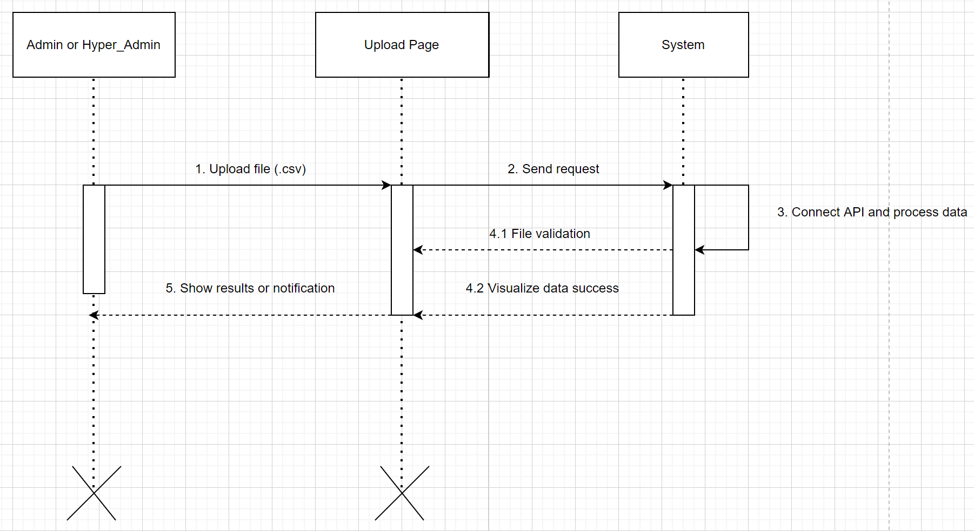

Figure ‑ : Admin sequence

## COMPONENT DIAGRAM

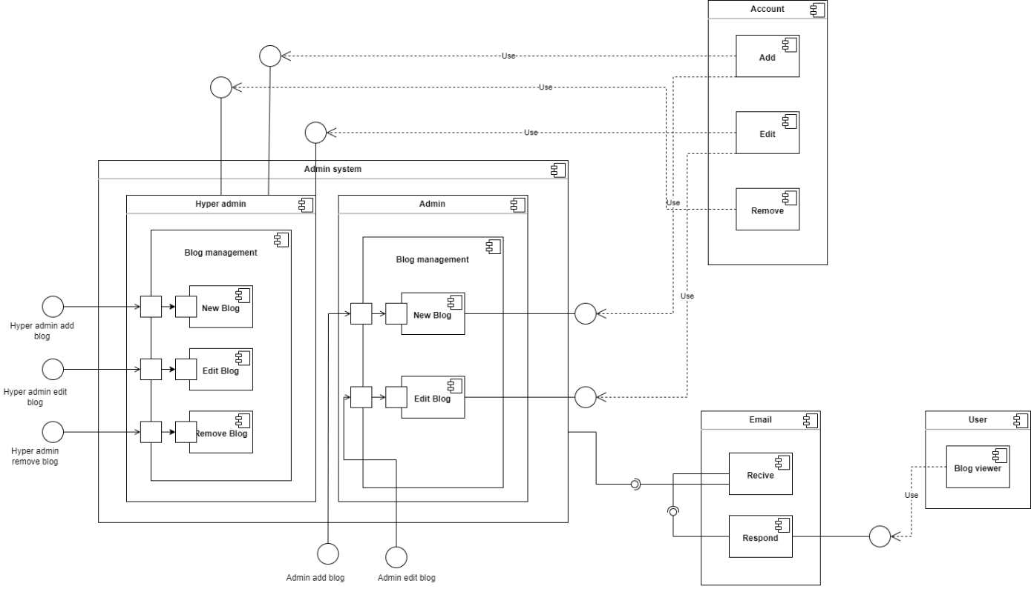

Figure ‑ : System Component

## IMPLEMENTATION

In this section, we build a website by using flask framework and javascript. In this website, we create some pages, such as login home page, about page, services page, contact page, news page and weather forecast page. Users can see blog posts in this website and contact with admin through contact page. In this website, admin and hyper admin can login by using their own accounts, weather forecast page is only used by admin and hyper admin to get the temperature predictions from model. They can also add blog posts and edit blog posts, but only hyper admin can remove blog posts. Hyper admin can manage the information of all admins in this website.

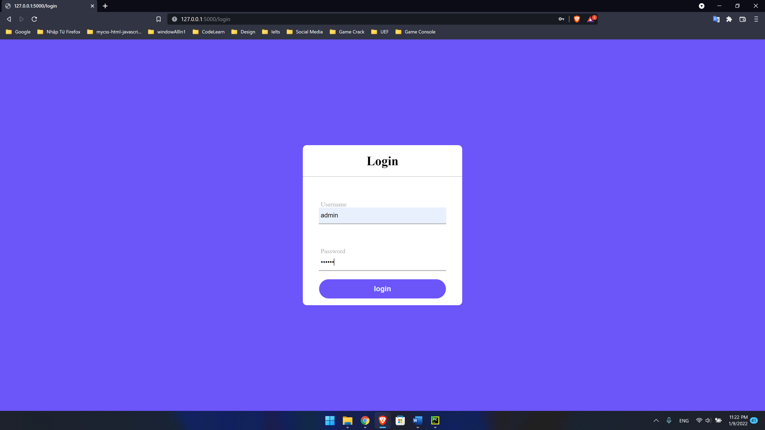

Figure ‑ : Login page



Figure ‑ : Home page



Figure ‑ : Details in home page



Figure ‑ : About page



Figure ‑ : Services page



Figure ‑ : News page



Figure ‑ : Blog page

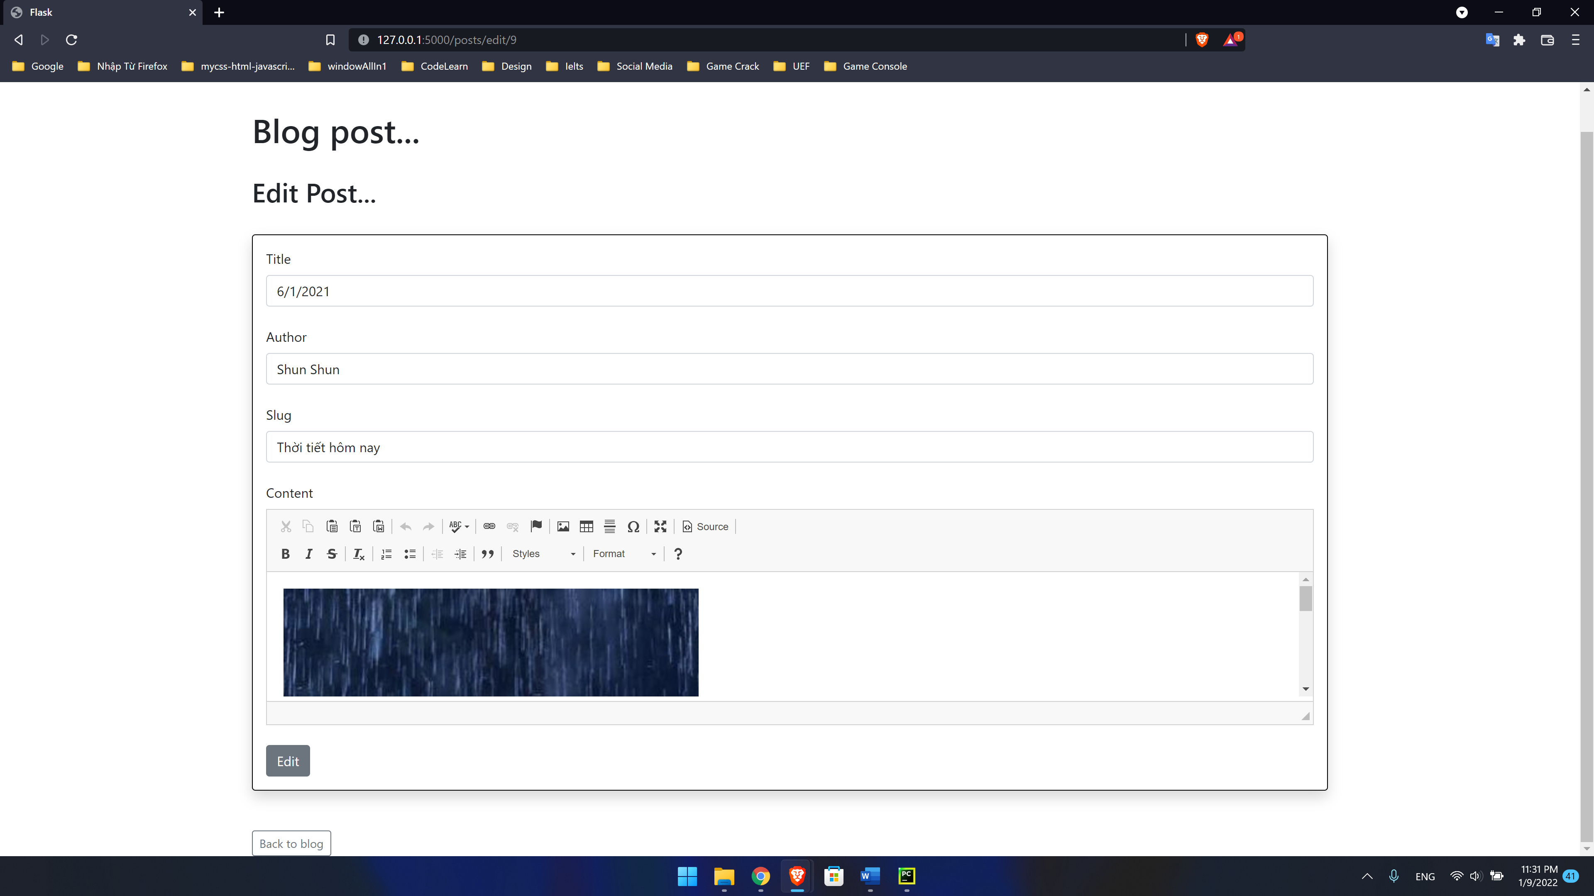

Figure ‑ : Blog post page



Figure ‑ : Contact page

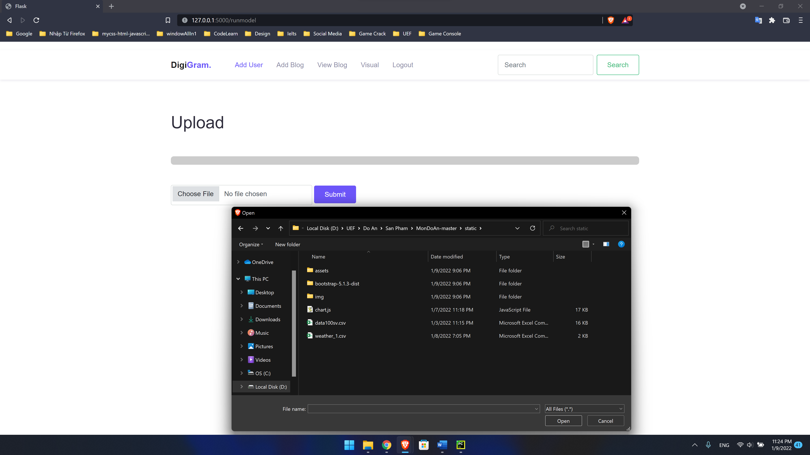

Figure ‑ : choosing weather dataset

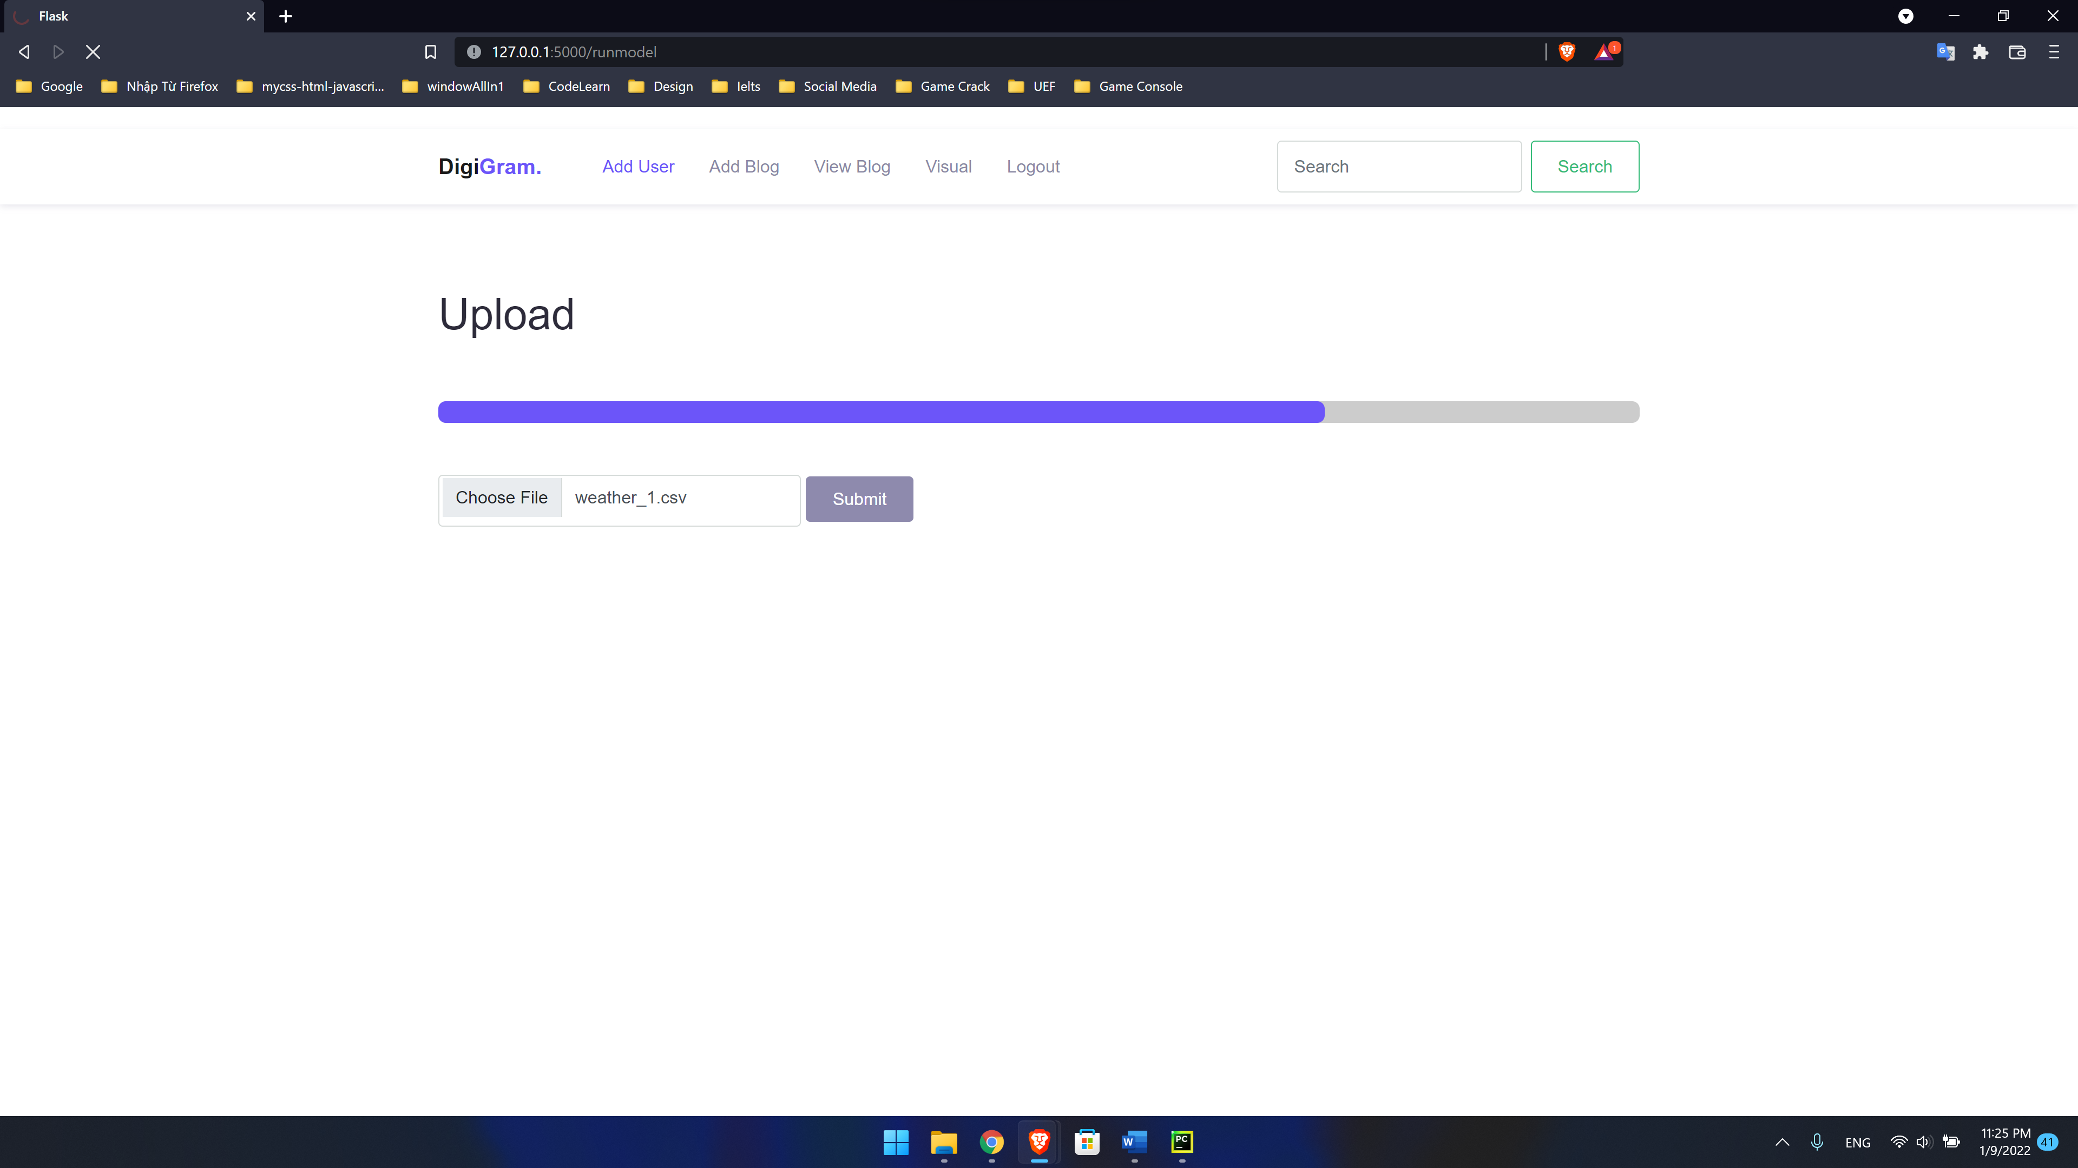

Figure ‑ : Uploading dataset

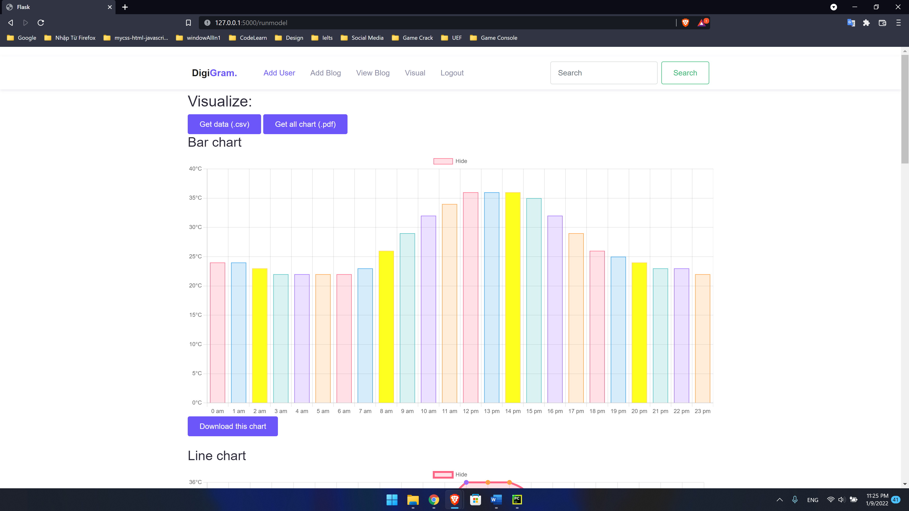

Figure ‑ : Visualizing predictions by bar chart

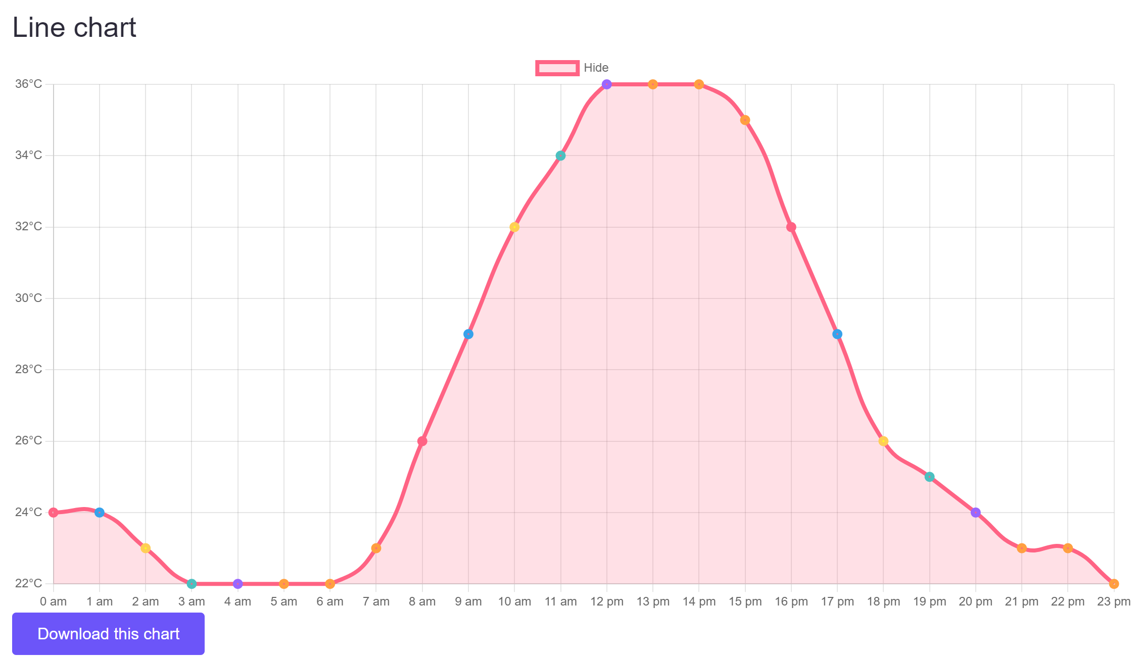

Figure ‑ : Visualizing predictions by line chart

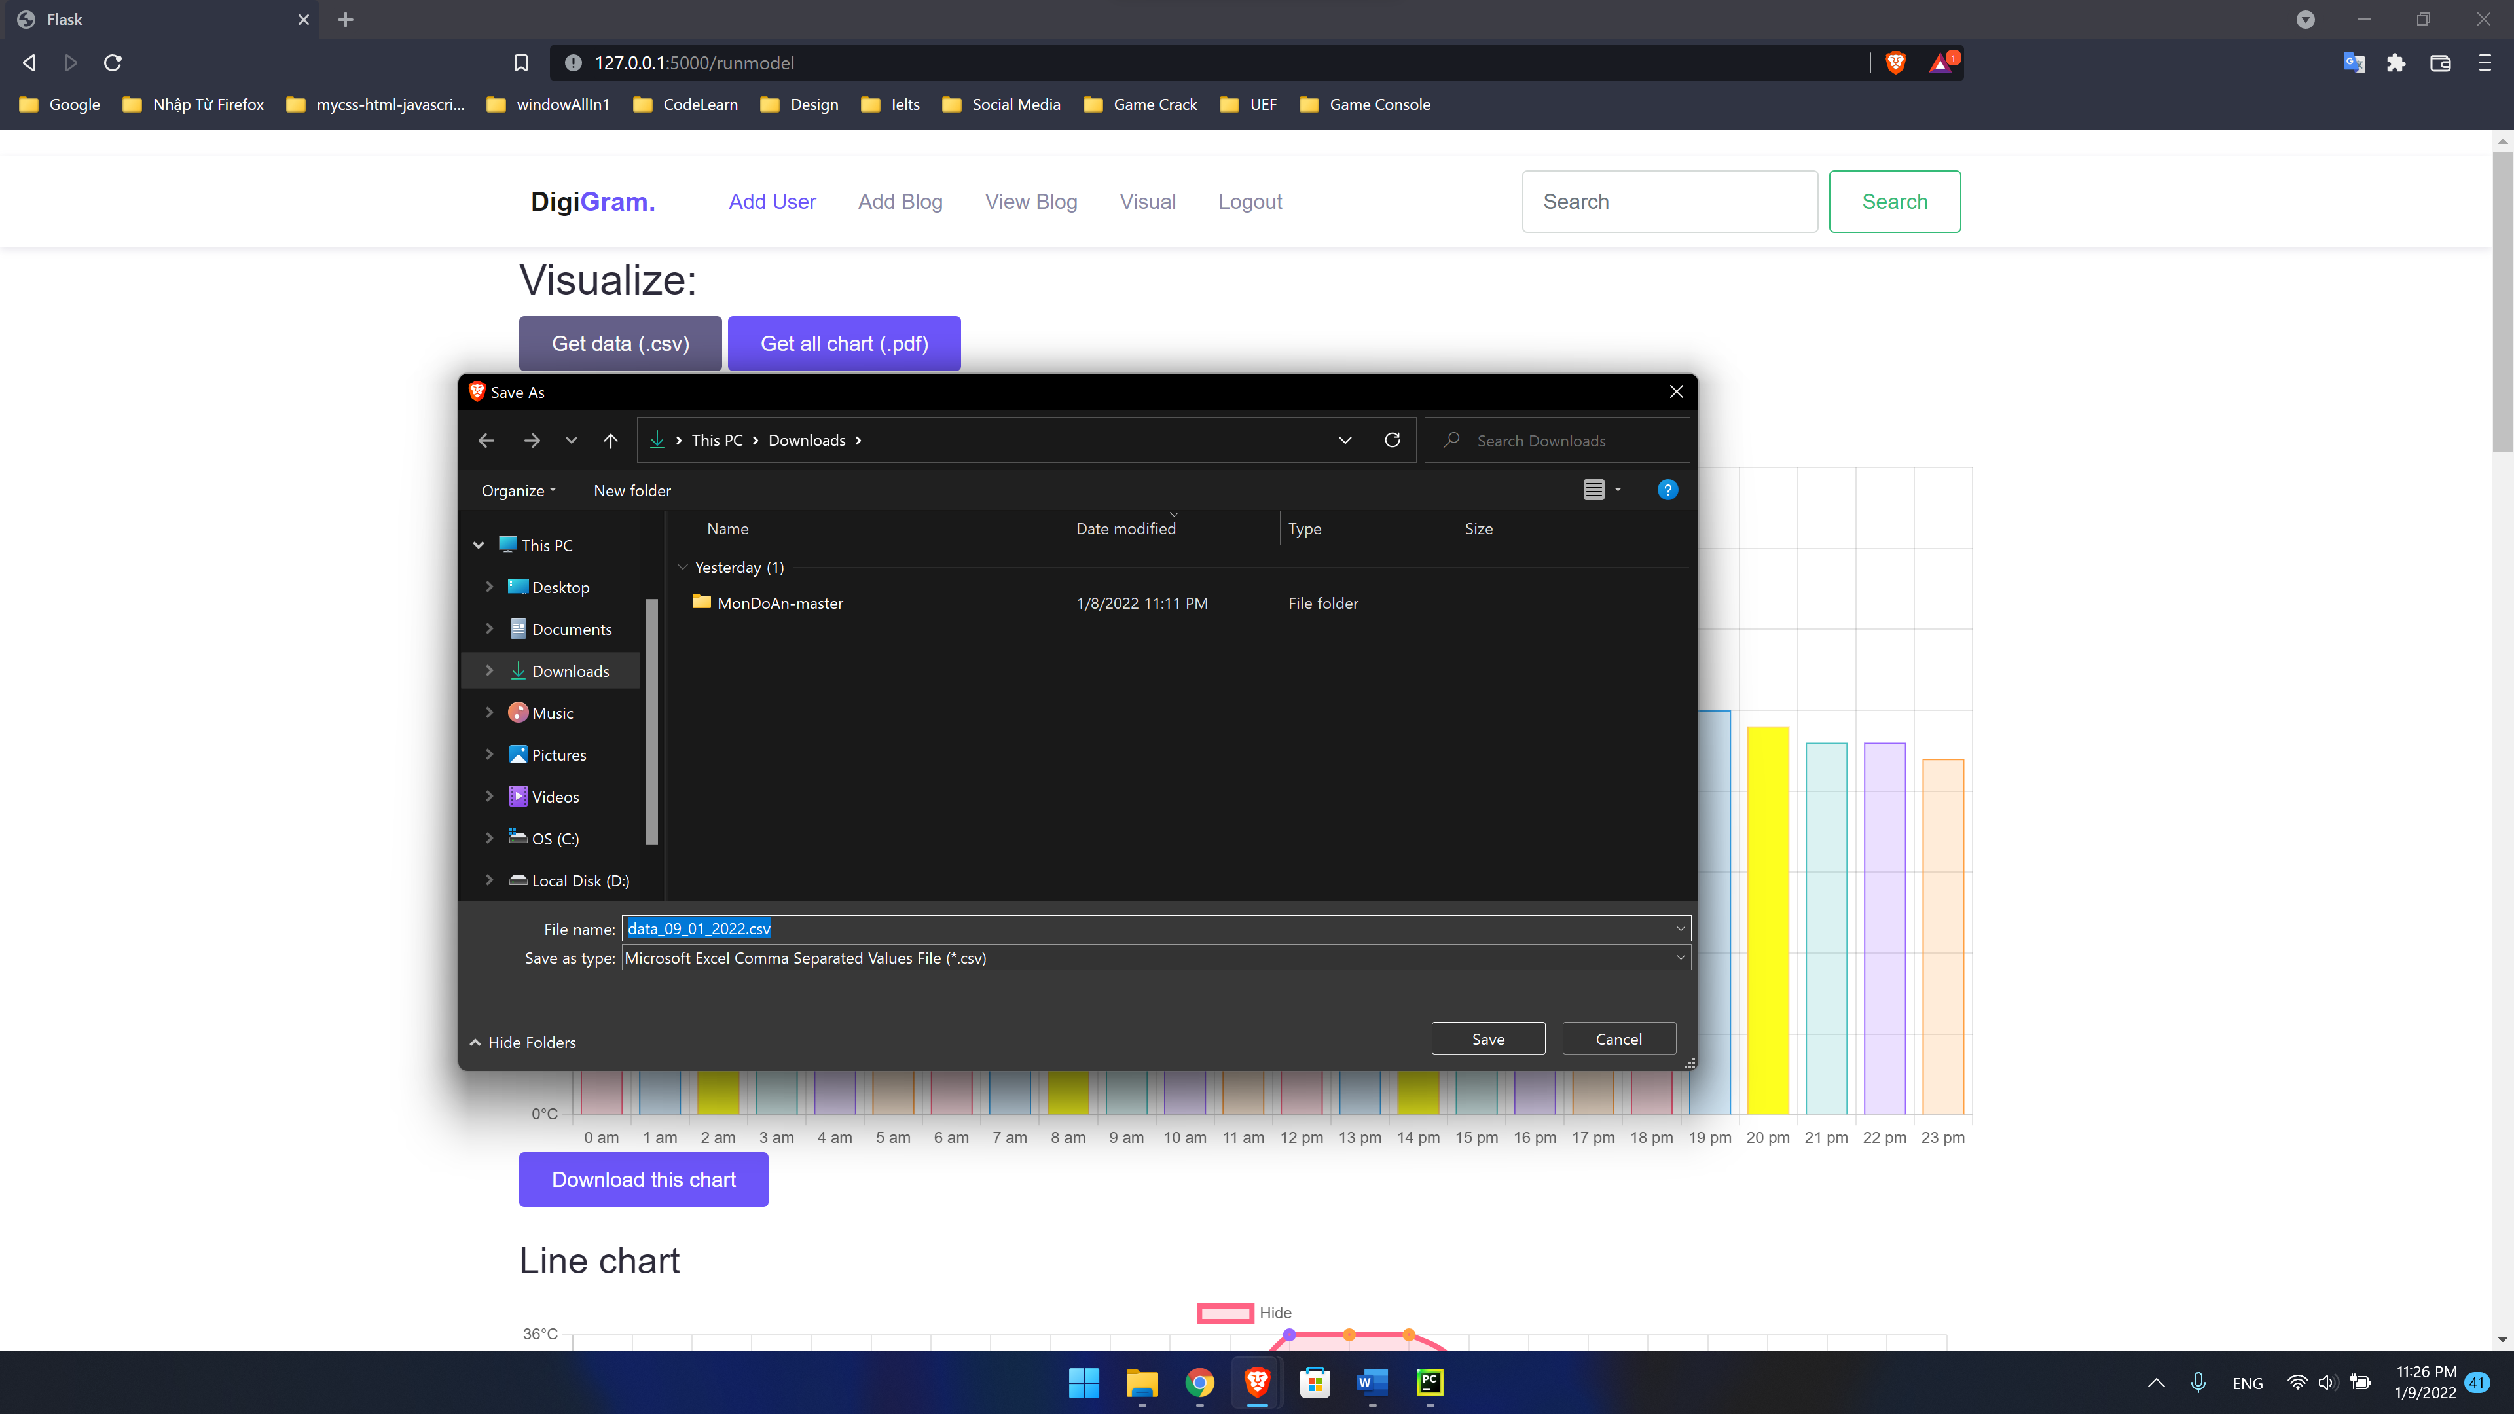

Figure ‑ : Download predictions

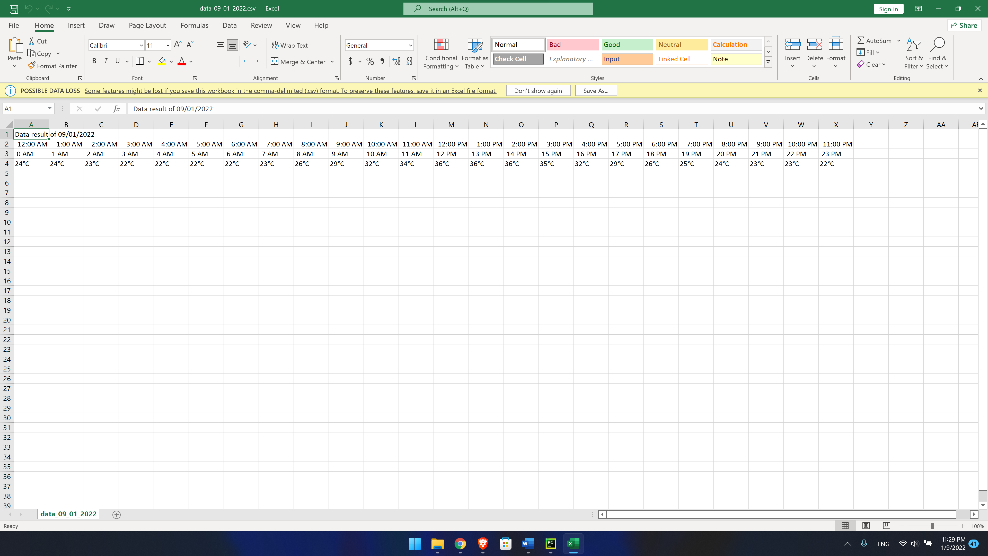

Figure ‑ : Predictions CSV file

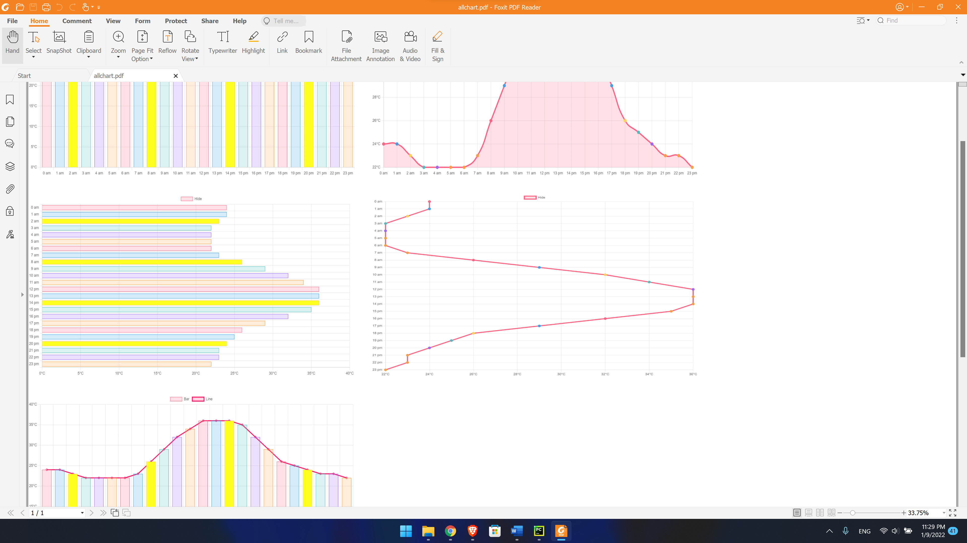

Figure ‑ : Predictions PDF file

# CONCLUSION

## RESULT

After analyzing and building up mathematical models to predict the weather in the future, we realize that Neural Networks is suitable for this problem and this dataset because the evaluation of Random Forest is better than KNN and Neural Networks models. Based on the Neural Networks model and the assistance of IBM Watson, we can apply the weather forecast model into a website to predict the temperature of the future. Besides, we also have a plan to develop this weather forecast website in the future, we will improve the interface of website and add some functions to make it better.

## LIMITATIONS

In the process of researching and developing mathematical models and website, we find out some limitations such as the constant change of weather, lack of dataset, processing and tech limits, public trust and human engineering. These limitations cause difficulties in modeling and website development.

# REFERENCES

* <https://www.kaggle.com/salmamaamouri/weather-prediction-regression-neural-model>
* <https://www.analyticsvidhya.com/blog/2021/05/detecting-and-treating-outliers-treating-the-odd-one-out/>

* <https://analyticsindiamag.com/5-ways-handle-missing-values-machine-learning-datasets/>

* <https://scikitlearn.org/stable/modules/generated/sklearn.ensemble.RandomForestRegressor.html>
* <https://myibm.ibm.com/dashboard/>
* <https://www.guru99.com/flask-vs-django.html>